**MongoDB Task-2**

**Design database for Zen class programme**

users

codekata

attendance

topics

tasks

company_drives

Mentors

**Answers:**

**Users:**

db.createCollection("users");

db.users.insertMany([

{

"user_id": "U001",

"name": "Naveen",

"email": "naveen@example.com",

"status": "active"

},

{

"user_id": "U002",

"name": "John Doe",

"email": "john@example.com",

"status": "active"

}

]);

**Codekata:**

db.createCollection("codekata");

db.codekata.insertMany([

{

"user_id": "U001",

"codekata_problems_solved": 150

},

{

"user_id": "U002",

"codekata_problems_solved": 200

}

]);

**attendance:**

db.createCollection("attendance");

db.attendance.insertMany([

{

"user_id": "U001",

"date": ISODate("2020-10-16"),

"status": "present"

},

{

"user_id": "U002",

"date": ISODate("2020-10-16"),

"status": "absent"

}

]);

**topics:**

db.createCollection("topics");

db.topics.insertMany([

{

"topic_id": ObjectId(),

"topic_name": "JavaScript",

"date": ISODate("2020-10-01")

},

{

"topic_id": ObjectId(),

"topic_name": "Node.js",

"date": ISODate("2020-10-15")

}

]);

**tasks:**

db.createCollection("tasks");

db.tasks.insertMany([

{

"task_id": ObjectId(),

"task_name": "Full Stack",

"user_id": "U001",

"submitted": true,

"date": ISODate("2020-10-05")

},

{

"task_id": ObjectId(),

"task_name": "MongoDB",

"user_id": "U002",

"submitted": false,

"date": ISODate("2020-10-07")

}

]);

**Company_drives:**

db.createCollection("company_drives");

db.company_drives.insertMany([

{

"drive_id": ObjectId(),

"company_name": "Google",

"date": ISODate("2020-10-20"),

"appeared_students": ["U001", "U002"]

},

{

"drive_id": ObjectId(),

"company_name": "Microsoft",

"date": ISODate("2020-10-25"),

"appeared_students": ["U002"]

}

]);

**mentors:**

db.createCollection("mentors");

db.mentors.insertMany([

{

"mentor_id": ObjectId(),

"name": "jeeva",

"mentee_count": 20

},

{

"mentor_id": ObjectId(),

"name": "giri",

"mentee_count": 10

}

]);

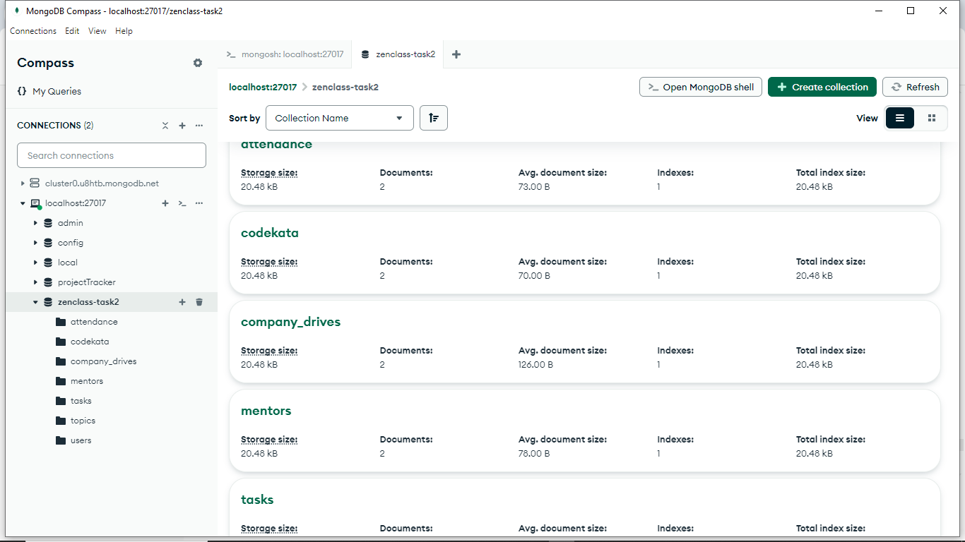

**1.Find all the topics and tasks which are thought in the month of October**

db.topics.find({

date: {

$gte: ISODate("2020-10-01"),

$lt: ISODate("2020-11-01")

}

});

db.tasks.find({

date: {

$gte: ISODate("2020-10-01"),

$lt: ISODate("2020-11-01")

}

});

**2. Find all the company drives which appeared between 15 oct-2020 and 31-oct-2020**

db.company_drives.find({

date: {

$gte: ISODate("2020-10-15"),

$lt: ISODate("2020-11-01")

}

});

**3. Find all the company drives and students who are appeared for the placement.**

db.company_drives.find({}, {

company_name: 1,

appeared_students: 1

});

**4.Find the number of problems solved by the user in codekata**

db.codekata.find({}, {

user_id: 1,

codekata_problems_solved: 1

});

**5.Find all the mentors with who has the mentee's count more than 15**

db.mentors.find({

mentee_count: { $gt: 15 }

});

**6.Find the number of users who are absent and task is not submitted between 15 oct-2020 and 31-oct-2020**

db.attendance.aggregate([

{

$match: {

status: "absent",

date: {

$gte: ISODate("2020-10-15"),

$lt: ISODate("2020-11-01")

}

}

},

{

$lookup: {

from: "tasks",

localField: "user_id",

foreignField: "user_id",

as: "tasks"

}

},

{

$match: {

"tasks.submitted": false

}

},

{

$count: "absent_and_not_submitted"

}

]);